Q.
Let be a 3cnf-formula. An ≠-assignment to the variables of is one where each clause contains two literals with unequal truth values. In other words, an ≠-assignment satisfies without assigning three true literals in any clause.
Let ≠SAT be the collection of 3cnf-formulas that have an ≠-assignment. Show that we obtain a polynomial time reduction from 3SAT to ≠SAT by replacing each clause ci (y1 y2 y3) with the two clauses (y1 y2 zi) and ( y3 b), where zi is a new variable for each clause ci and b is a single additional new variable.
Solution:
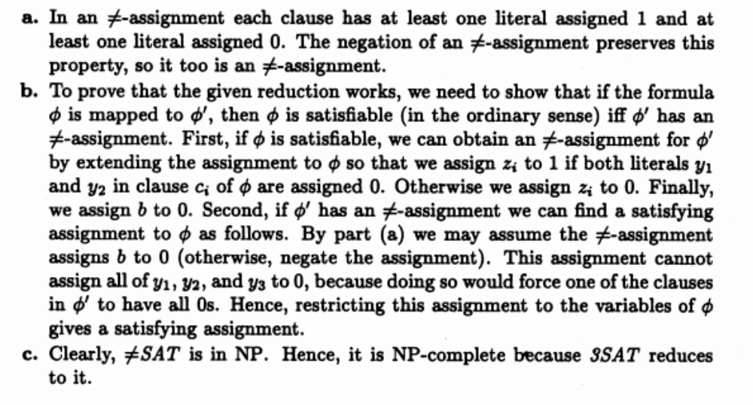
Q. Show DOMINATING-SET is NP Complete by giving a reduction from Vertex Cover.

OR

A subset of nodes of a graph is a dominating set if every other node of G is adjacent to some node in the subset. Let DOMINATING-SET={<G, k> | G has a dominating set with k nodes}. Show that it is NP-Complete by giving a reduction from VERTEX-COVER
Solution:
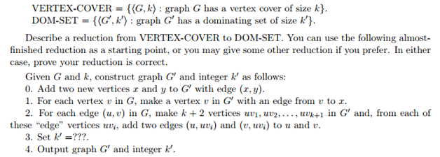
OR
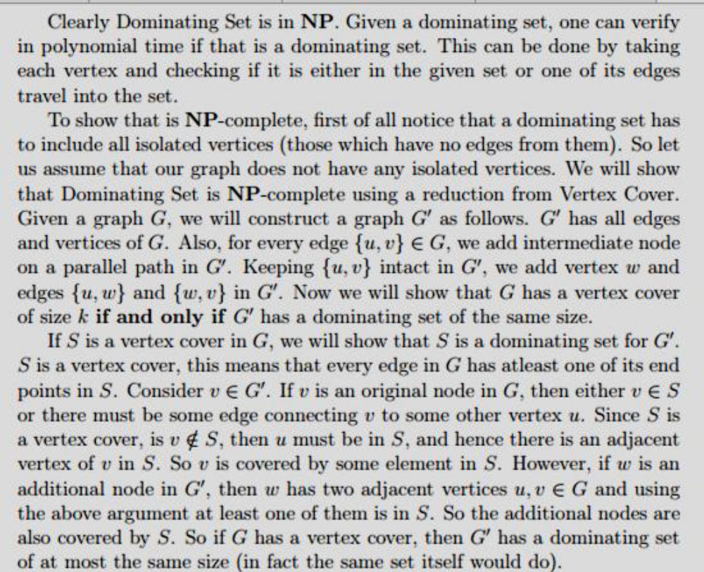

Q. Let PAL-ADD = {<x, y> | x, y >0 are binary integers where x + y is an integer whose binary representation is palindrome}. Show that PAL-ADD ϵ LSPACE.
Solution:
M1 = “On input string w:
1. Scan across the tape and look for 0s and 1s
2. Count number of 0s separately
3. Count number of 1s separately
4. compare both the counters if both are equal accept, otherwise reject the machine counts the number of 0s and, separately, the number of 1s in binary on the work tape. The only space required is that used to record the two counters. In binary, each counter uses only logarithmic space and hence the algorithm runs in O(log n)space. Therefore, A є L.
