Virtual University of Pakistan Fall 2016

CS703 – Advanced Operating Systems 50
Assignment No. 2
Question No. 1 (10 marks) 10
Give two differences between user-level threads and kernel-level threads? Under what circumstances is one type better than the other?
Answer:
- User-level threads are threads that the OS is not aware of. They exist entirely within a process, and are scheduled to run within that process's time-slices.
- The OS is aware of kernel-level threads. Kernel threads are scheduled by the OS's scheduling algorithm, and require a "lightweight" context switch to switch between (that is, registers, PC, and SP must be changed, but the memory context remains the same among kernel threads in the same process).
- User-level threads are much faster to switch between, as there is no context switch; further, a problem-domain-dependent algorithm can be used to schedule among them.
- CPU-bound tasks with interdependent computations, or a task that will switch among threads often, might best be handled by user-level threads.
- Kernel-level threads are scheduled by the OS, and each thread can be granted its own time slices by the scheduling algorithm. The kernel scheduler can thus make intelligent decisions among threads, and avoid scheduling processes which consist of entirely idle threads (or I/O bound threads). A task that has multiple threads that are I/O bound, or that has many threads (and thus will benefit from the additional time slices that kernel threads will receive) might best be handled by kernel threads.
- Kernel-level threads require a system call for the switch to occur; user-level threads do not.

Question No. 2 (15 marks) 15
Revive the Readers/Writers problem discussed in lecture 12, write the code for function Writer() when readers are given priority over writers, keeping the problem constraints in mind?
Answer:
Writer () {
Lock.Acquire();
While((AR + WR + AW) > 0) {
WW++;
okToWrite.Wait(&lock);
WW--;
} // while
AW++;
Lock.Release();
Access DB
Lock.Acquire();
AW-- ;
If (WR > 0) {
okToRead.Broadcast(&lock);
} else if(WW > 0) {
okToWrite.Signal(&lock)
lock.Release();
}
}
Question No. 3 (8 + 8 + 8 + 1 = 25 marks) 25
Consider the following set of processes, with the length of the CPU-burst time given in milliseconds:
Process | Burst Time | Priority
P₁ | 10 | 3
P₂ | 1 | 1
P₃ | 2 | 3
P₄ | 1 | 4
P₅ | 5 | 2

The processes are assumed to have arrived in the order P1, P2, P3, P4, P5, all at time 0.

- Draw four Gantt charts illustrating the execution of these processes using FCFS, SJF, a nonpreemptive priority (a smaller priority number implies a higher priority), and RR (quantum = 1) scheduling.
- What is the turnaround time of each process for each of the scheduling algorithms in part a?
- What is the waiting time of each process for each of the scheduling algorithms in part a?

Answer:
The four Gantt charts with
1. FCFS:

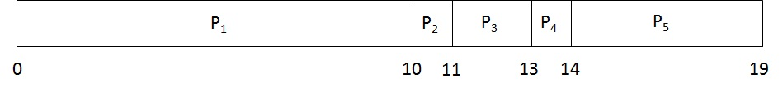

Performance statistics as are blow:

Process | Arrival Time | Burst Time | Priority | Finish Time | Turnaround Time | Waiting Time
P₁ | 0 | 10 | 3 | 10 | 10 | 0
P₂ | 0 | 1 | 1 | 11 | 11 | 10
P₃ | 0 | 2 | 3 | 13 | 13 | 11
P₄ | 0 | 1 | 4 | 14 | 14 | 13
P₅ | 0 | 5 | 2 | 19 | 19 | 14
Average |  |  |  |  | 13.4 | 9.6

2. SJF (Non-preemptive):

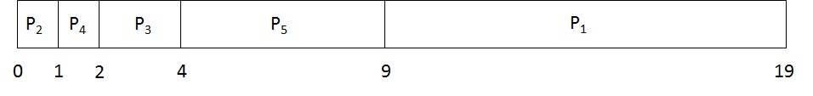

Performance statistics as are blow:

Process | Arrival Time | Burst Time | Priority | Finish Time | Turnaround Time | Waiting Time
P₁ | 0 | 10 | 3 | 10 | 19 | 9
P₂ | 0 | 1 | 1 | 1 | 1 | 0
P₃ | 0 | 2 | 3 | 4 | 4 | 2
P₄ | 0 | 1 | 4 | 2 | 5 | 1
P₅ | 0 | 5 | 2 | 9 | 9 | 4
Average |  |  |  |  | 7 | 3.2

3. SJF (Preemptive, Shortest-next-CPU-burst):
In this case the processes all arrive at the same time. This method turned out to be the same as non-preemptive SJF.

Performance statistics as are blow:

Process | Arrival Time | Burst Time | Priority | Finish Time | Turnaround Time | Waiting Time
P₁ | 0 | 10 | 3 | 19 | 19 | 9
P₂ | 0 | 1 | 1 | 1 | 1 | 0
P₃ | 0 | 2 | 3 | 4 | 4 | 2
P₄ | 0 | 1 | 4 | 2 | 2 | 1
P₅ | 0 | 5 | 2 | 9 | 9 | 4
Average |  |  |  |  | 7 | 3.2

4. Non-preemptive, Priority:

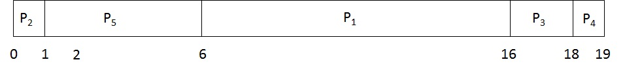

Performance statistics as are blow:

Process | Arrival Time | Burst Time | Priority | Finish Time | Turnaround Time | Waiting Time
P₁ | 0 | 10 | 3 | 16 | 16 | 6
P₂ | 0 | 1 | 1 | 1 | 1 | 0
P₃ | 0 | 2 | 3 | 18 | 18 | 16
P₄ | 0 | 1 | 4 | 19 | 19 | 18
P₅ | 0 | 5 | 2 | 6 | 6 | 1
Average |  |  |  |  | 13.4 | 8.2

5. Round Robin:

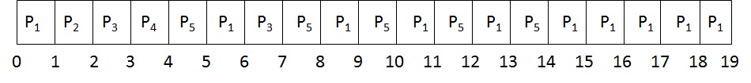

Performance statistics as are blow:

Process | Arrival Time | Burst Time | Priority | Finish Time | Turnaround Time | Waiting Time
P₁ | 0 | 10 | 3 | 19 | 19 | 9
P₂ | 0 | 1 | 1 | 2 | 2 | 1
P₃ | 0 | 2 | 3 | 7 | 7 | 5
P₄ | 0 | 1 | 4 | 4 | 4 | 3
P₅ | 0 | 5 | 2 | 14 | 14 | 9
Average |  |  |  |  | 9.2 | 5.4

- Which of the schedules in part a results in the minimal average waiting time (over all processes)?

Average Waiting Time:

Algorithm | Average Waiting Time
FCFS | 9.6
SJF (Non-preemptive) | 3.2
SJF (Preemptive, Shortest-next-CPU-burst) | 3.2
Non-preemptive, Priority | 8.2
Round Robin | 5.4

Therefore, SJF (either Non-preemptive algorithm or preemptive algorithm, since they give the same result in this case) has the minimum average waiting time.

