1. Write a note on complete-ness and reconstruction of VF
2. Differentiate between fully and partially databases and vertical and horizontal fragmentation
– fully replicated: each fragment at each site
– partially replicated: each fragment at some of the sites
3. Write a note on need for distributed database. Why it's more beneficial? What is meant by optimality?
- Major two reasons that make an application a candidate to be DDBS application
- Large Number of Users
- Operation spread large geographical area

Advantages[edit]
- Management of distributed data with different levels of transparency like network transparency, fragmentation transparency, replication transparency, etc.
- Increase reliability and availability
- Easier expansion
- Reflects organizational structure — database fragments potentially stored within the departments they relate to
- Local autonomy or site autonomy — a department can control the data about them (as they are the ones familiar with it)
- Protection of valuable data — if there were ever a catastrophic event such as a fire, all of the data would not be in one place, but distributed in multiple locations
- Improved performance — data is located near the site of greatest demand, and the database systems themselves are parallelized, allowing load on the databases to be balanced among servers. (A high load on one module of the database won't affect other modules of the database in a distributed database)
- Economics — it may cost less to create a network of smaller computers with the power of a single large computer
- Modularity — systems can be modified, added and removed from the distributed database without affecting other modules (systems)
- Reliable transactions - due to replication of the database
- Hardware, operating-system, network, fragmentation, DBMS, replication and location independence
- Continuous operation, even if some nodes go offline (depending on design)
- Distributed query processing can improve performance
- Single-site failure does not affect performance of system.
- For those systems that support full distributed transactions, operations enjoy the ACID properties:
  - A-atomicity, the transaction takes place as a whole or not at all
  - C-consistency, maps one consistent DB state to another
  - I-isolation, each transaction sees a consistent DB
  - D-durability, the results of a transaction must survive system failures
The Merge Replication Method is popularly used to consolidate the data between databases

4. What are complete predicates? Minterm predicates?
5. Write the formula to calculate affinity matrix?
6. Explain (A1, D2, H1) (A1, D0, H1) architectures of DBMS.
7. What is autonomy? What are its types? How it's classified?
8. Write a note on fragmentation. Its advantages and disadvantages.
9. To make affinity matrix (10 marks)
10. To make affinity matrix. Describe the contribution of moving attribute A4 between A1 and A2.
11. Attribute Usage Matrix for given queries
12. Components of DDBMS
DDBMS components
• Computer workstations (sites or nodes) that form the network system.
• Network hardware and software components that reside in each
workstation.
• Communications media that carry the data from one workstation to
another.
• The transaction processor (TP), which is the software component
found in each computer that requests data. The transaction processor
receives and processes the application’s data requests (remote and local).
The TP is also known as the application processor (AP) or the
transaction manager (TM).

• The data processor (DP). which is the software component residing
On each computer that stores and retrieves data located at the site.
The DP is also known as the data manager (DM). A data processor
may even be a centralized DBMS.

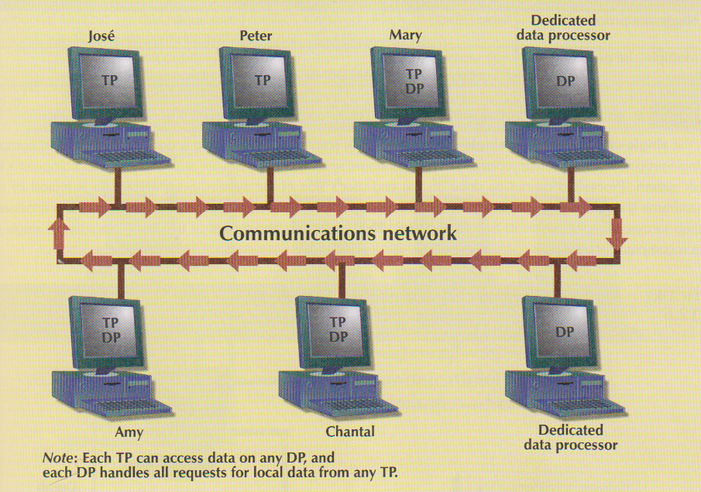

The protocols determine how the distributed database system will:
• Interface with the network to transport data and commands between
data processors (DPs) and transaction processors (TPs).
• Synchronize all data received from DPs (TP side) and route retrieved
data to the appropriate TPs (DP side).
• Ensure common database functions in a distributed system .
13. Working of DDBMS Components and their Interfacing
14 Star and bus topology
15. Global schema ki importance in DDBS

Global Conceptual Schema
The global conceptual schema is a logical description of the whole database, as if it were not distributed. This level corresponds to the conceptual level of the ANSI-SPARC architecture and contains definitions of entities, relationships, constraints, security and integrity information. It provides physical data independence· from the distributed environment. The global external schemas· provide logical data independence.
16. Rules for correctness.
17. kia fragments DDBMS ki semantic ko change krtihy.
18. Table thausy 2nd normal form mailikhnatha
19. empky table ki PHF krnithi Location wise
20. Affinity matrix k sath CA bnanatha ( lect 19 )
21. What is meant by complete and minimal predicates? ( in PDF )
Minimality
Minimal :If all the predicates of a set Pr are relevant, Pr is minimal. That is, there should be at least one application that accesses fragments fi and fj differently. i.e., The simple predicate pi should be relevant in determining a fragmentation.

22. Write ways of user access data from DDBMS?
23. Describe software component of replication? ( lect 21 )
24. How we remove transitive dependency? ( normalization PDF )
25. Independences of Distributed Database
1.Local Independence (Location Transparency)
Users should not have to know where data is physically stored, but rather should be able to behave (at least from a logical standpoint) as if the data were all stored at their own local site.

2. Fragmentation Independence (Fragmentation Transparency)
The user sees only one single logical database. Data fragmentation is transparent to the user. The user does not need to know the name of the database fragment in order to retrieve them.
Note: A system supports data fragmentation if a given Table can be divided up into pieces or fragments for physical storage purposes. Fragmentation is desirable for performance reasons: Data can be stored at location where it is most frequently used, so that most operations are local and network traffic is reduced.

3. Replication Independence (Replication Transparency)
The user sees only one single logical database. The DDBMS transparently select the database fragment to access. The DDBMS manages all fragments transparently to the user.
Note: A system supports data replication to the storage of data copies at multiple sits served by a computer network. Fragment copies can be stored at several sites to serve specific information requirements. Because the existence of fragment copies can enhance data availability and response time, data copies can help to reduce communication and total query costs.
4.Hardware Independence
The system must run the same DBMS on different hardware platforms, and furthmore to have different machines all participate as equal partners in a distributed system.

5. Operating System Independence
The system must run the same DBMS on different operating system Platforms including different operating systems on the same hardware and have (e.g.) an MVS version and a UNIX version and an NT version all participate in the same distributed system.

6. Network independence
The system must support a variety disparate communication networks.

7. DBMS Independence
The system must support any vendor's database product. The DBMS instances at different sites all support the same interface - they do not necessarily all have to be copies of the same DBMS software. The ideal distributed system should be heterogeneous and should provide DBMS independence.

Fragmentation Independence
Fragmentation independence refers to the ability of end users to store logically related information at different physical locations. There are two types of fragmentation independence: vertical partitioning and horizontal partitioning. Horizontal partitioning permits different rows of the same table to be stored at different remote sites. This is commonly done by organizations that maintain several branch offices, each with an identical set of table structures.
Vertical partitioning refers to the ability of a distributed system to fragment information such that the data columns from the same logical tables are maintained across the network. Oracle accomplishes this with Oracle views that hide specific columns and rows in a table.
26. Inputs needs for distributed database
The inputs of the distributed database design phase are relational database tables. The outputs of the distributed database design phase are the distribution schema indicating the location of data and processes.

27. Differentiate between Bus and ring Topology
28. About Horizontal Fragmentation, Owner and member relation
29. Differentiate between VF and HF

