CS713 – Object Oriented DBMS

Due date: 23-7-2016
Total Marks 50

MS150400558

Assignment 3

25+25
Q.1
We are familiar with the data storage concept in Relational DBMS that we store data in the form of tables. What do you think about the storage of objects in Object Oriented DBMS, either you will store objects in the form of columns or rows? Explain your answer with the help of examples. 25

Answer:
It is possible to store objects In the form of column because in the relational data model the data is stored in the form of column and rows and each tuple is accessible through PK the value of PK is assigned by the user of the DBMS or DBA but of that value of the PK is changed it become a new row in the relation other hand the Object is based on OID that is unique in the system not if the value mean state and behavior of the object is changed it also remain same not left his position of the column. Because many time the OID is used by the DB and also assigned by DB so the user of the system is not responsible for identification of the objects in a system.

Object it is not necessary that object is a real thing it may be a tangible thing. A system that we models and there exists anything that we different from other things that can be call object. In the object oriented database the basic paradigm is object, object is a basic building block and the abstraction guides us how to identified the objects, find accusation between objects and modeling the object, while identifying the object or modeling the object we do not focus on the state of the object also on the behavior of the object. The concept of the object resembles the concept of entities. essentially both are the same but one major difference the entity or entity type model only sate of the things or state of the real world object whereas the object model not only state of the object but also its behavior . The state of the object is model through attribute when we define an object we identified different properties of the object and those property are modeled through attribute. The attribute in object model are more powerful has more capabilities in the relational data model the attribute has basic data type or an attribute can store a single value. The object model the attribute has many more data types it is not restricted as in the relational data model. Every object is identified able through OID. OID is a value that is assigned to an object is unique across the system.

Storage of objects in Object Oriented DBMS:

In the object oriented database system object hierarchy that we see in the Memory is same stored on the Disk, mean same hierarchy is available in RAM and Disk. It is not easy to represent same hierarchy on disk and RAM there is many underline operation that DBMS do to store that hierarchy. Object are totally used in any application updates deletes of any other operation are retrieved on RAM or Disk are represented in the form of object. Two approaches are similar in that in both storage, pages are stored in primary storage (RAM) or stored on secondary storage. That storage is called single level storage model.
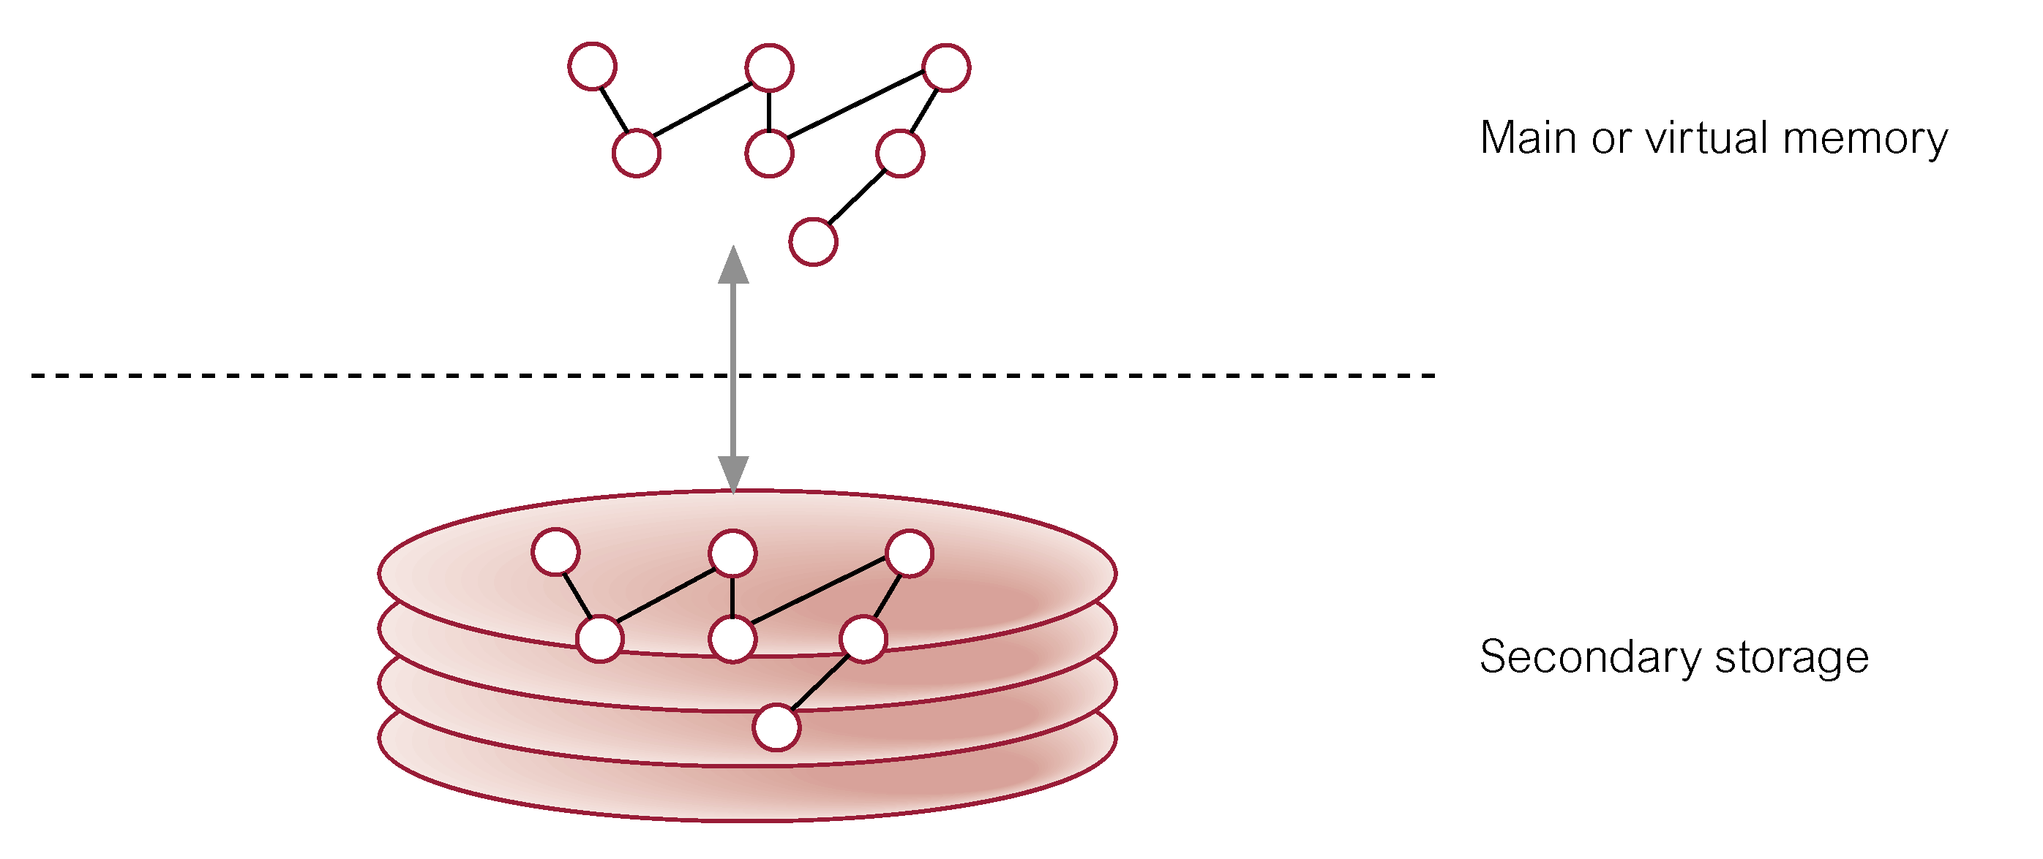

Although single level storage model is seam very efficient but very smartly object database do many operation that we cannot know. Here all links of objects, composition and their linking are based on OID. OID is very important feature of the Object DBMS. In the system there are two types of OID are implements Logical OID and Physical OID.

Logical ID; independent of physical storage of object. It id independent from Actual or physical location of the object. Mean it has no concern from actual location on disk its concern only on RAM.
Physical OID; encodes location. In this type of implementation physical location of sector reflect or included into OID
In the persistence of objects we deal with storage of the objects when objects come into RAM from Disk the physical OID cannot work because it is old Disk address that is changed from Memory OID. Its mean we need both OIDs to deal with storage of the Objects. We need logical OID to use in RAM and need physical OID to store on the Disk its mean OODBMS has to switch between the two types of OIDs. For the purpose of storing object on disk and access into RAM a Pointer Swizzling Techniques is used to change the Physical OID into logical OID. The action of converting objects identifiers (OIDs) to main memory pointers also called object faulting. While storing we need to convert logical to physical OID and while accessing into RAM OID is covert into physical to logical.

Store objects in the form of columns or rows:
There is a naïve approach we directly implement object oriented feature in a relational DB. That mean the objects can store in the form on relation tables. The class can be transformed into relation and for manipulation of class we reform or write special SQL query .for example
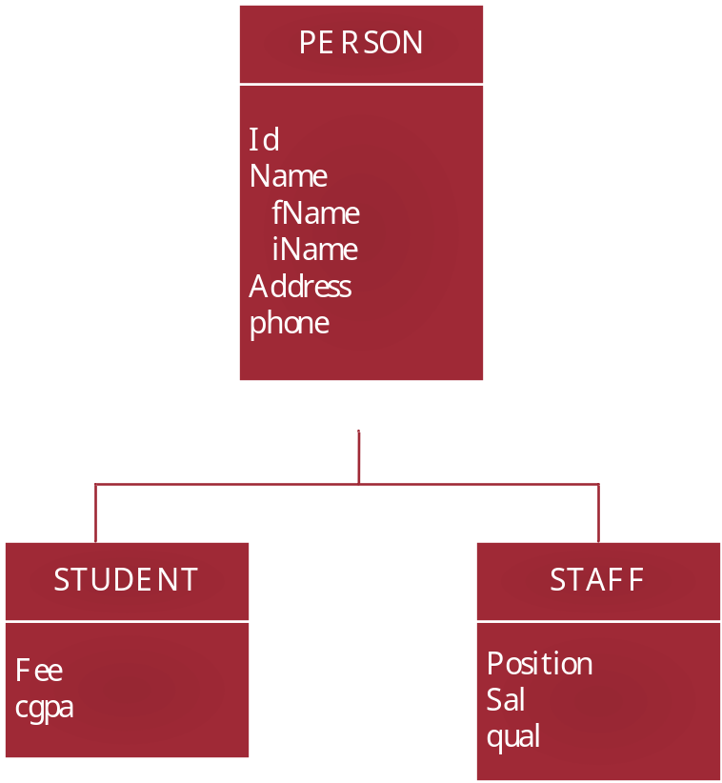
We ha class hierarchy in this hierarchy we have a super class PERSON and two subclasses STUDENT and STAFF suppose we implement through naïve approach. We transform these classes into relation there are many approach one is that we transform both super and sun classes into relation.
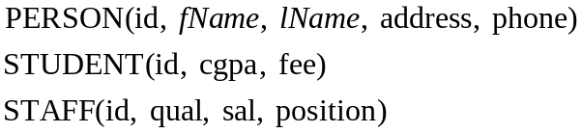
In this approach the PK Is used into all three relations .and we established a link between them.
In the 2nd approach we implement only Sub classes in relation as like
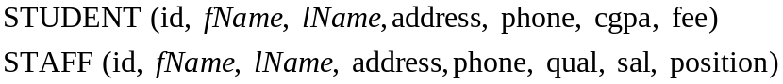
In this approach the attribute of super class repeat in to subclass. Due to inheritance attribute of super class are avail into subclasses so when we transform it into relation we copy all relation into both sub classes.
There is a third approach is available that is we convert all classes into single relation as like.
SQL operations need to be adjusted accordingly for the insertion/deletion operations on objects.
There is a single relation all attributes of super and subclasses comes into single relation. It’s mean if represent staff we use same tuple for that is used for student. It is naive approach that is used to store the objects in the form of relation.

There are two approaches that are used to build an object DB one is Object Relational DBMS (in this approach object feature are implemented on the top of Relational database, the underline structure is same of relational but on the level schema object feature are added to give the flavor of the object oriented programming) the 2nd approach is originally OODBMS approach (in this approach). Both approaches have different technique to store objects.
The OODBMS provides misconception of single storage model that is same representation in both memory and in the database stored on disk. In the object relational approach data can be stored in the form of tables, column and rows.in this approach two level storage approach in implemented in this approach the object that are shown in RAM are different from that are show on the Disk. This way objects are shown in the RAM are not represented on the Disk for example in this diagram.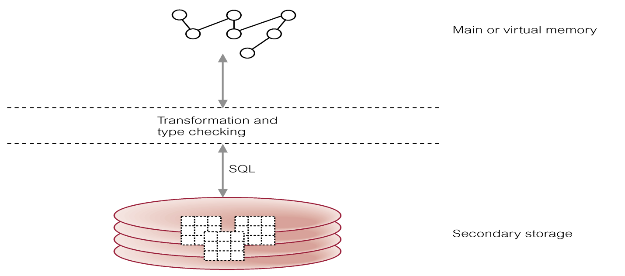 Two level Storages mechanism is shown. We see an object hierarchy in the RAM but actual in Disk it is stored in the form of Table) that mean it is possible to store objects in the form of table.

Q.2
Performance wise which one is more efficient approach in OODBMS Varrays or nested tables. Write a detailed note on the storage mechanism of nested tables and Varrays in Object oriented DBMS. 25

Answer:
By performance a nested table is more efficient then Varray A Nested table are to be measured as single-column table which can stored to be in memory, or as a column in a database table of the disk storage. Higher-level ways to organize and access data in the database provide Object types and related object-oriented features, such as Varrays and nested tables. Objects are stored in parent table as like a raw value. The inline storage technique has no needed of storage clause specification, unique identifier or separate storage table to store objects or relation. More ever some unique situations when the varray cross its limit of 4 K data, Oracle implements out-of-line storage technique and stores varray as an LOB on the disk for permanent storage. The number of IOs on the disk is reduced by the use of inline storage mechanism in Oracle. This technique make possible of Varrays to be superior and more performance efficient as compare to nested tables of data collection types.
Varrays:

In the Object relational DBMS (Oracle) many user defined types is created, Varray is an array we understand this collection type whit syntax. Costly SQL joins are avoiding by Varray tables that is it’s benefit, when they were stored then they can keep the order of the varray items based upon the sequence of the Varray. Though, the full-table scans to run longer because row length of varray tables is longer. Due to which items inside the varray cannot be indexed. When the number of repeating items is unknown or very large it is more important that varrays cannot be used. Varray tables are also complicated because the non-standard SQL is very ungainly and difficult to use.

General Syntax:
Create or replace (replace is used so far if object with same name is already created so replace it with new) than give the object name as here we say Varray and then give elements types of array for example.

Example:
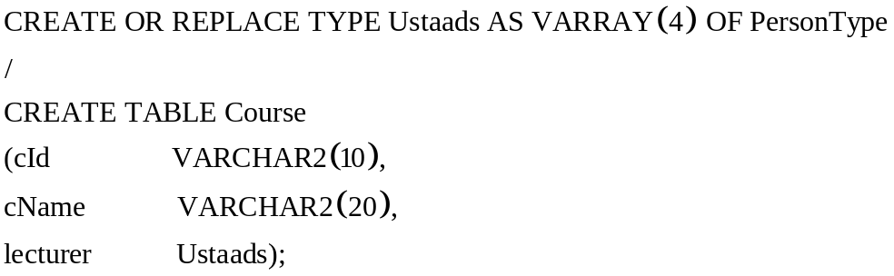
In this example we create an array with user defined type with four elements and this types or Varray is described again reputedly. Then create a table with already exist types of Oracle. Already defined array is used in this table as lecture types id Ustaads mean four elements of array each has person types. We may handle a situation where four teachers teach one course.

Nested Tables:

In the relational table says in single cell contain single value it is a basic thing. Because we create user defined types so far now we stored in a single column a complete table in it. This situation called nested table. Mean table within a table. Nested tables are similar to index by table but these can be stored in database columns but index by tables cannot be stored in database columns. Where e store a single attribute a single value now stored a complete table on this column. A nested table is quite similar to a VARRAY with the exception that the order of the elements is not static. In the oracle we can create multiple level of the table.
General Syntax:
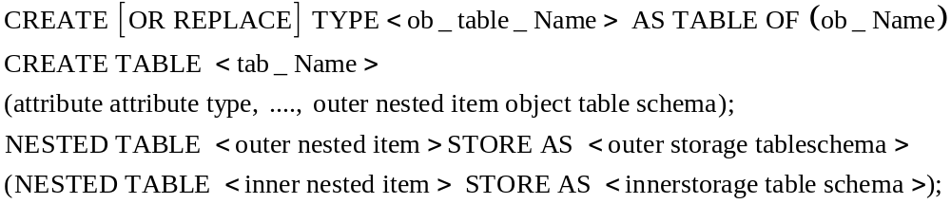
First we create a type then create a table as the types created already on the 2nd level we use that table type within a table as table type that become a nesting.
Example:
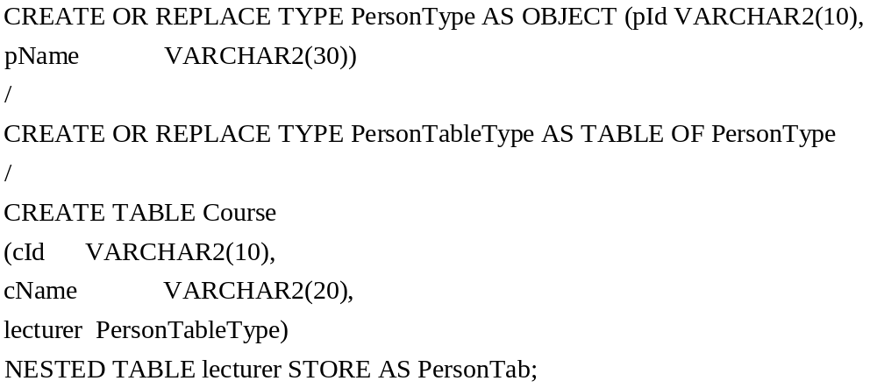
In this example first we create a type person type. Then we create a table with replace or create a table of person table type. Its mean we create a type that is person type. Mean that type is a complete and it is person type that is already defined. Next for nesting we create a table of Course CID and Cname both are regular definition next we give lecturer with PersonTableType here is a nesting involve and close it and say store as a Persontab; in this example the table PersonTab is a nested table part of the lecturer table as an attribute but it is complete table that is stored separately. Oracle offer multiple level of nesting

