FRAME FORMATS

Ethernet Packet Frame
- Preamble allows the receiver to synchronize with signal
- Frame must contain at least 46 bytes to detect collision
- 802.3 standard substitutes length with type field
  - Type field (demux key) is the first thing in data portion
  - A device can accept both frames: type > 1500
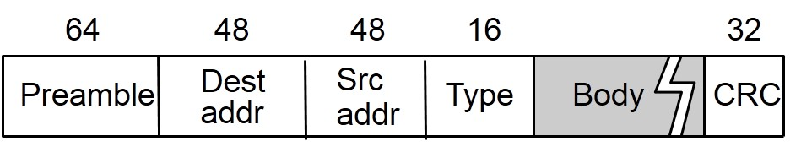

Token Ring Frame Format
- “Illegal” Manchester codes in the start and end delimiters
- Frame priority and reservation bits in access control byte
- Demux key in frame control byte
- A and C bits for reliable delivery, in status byte
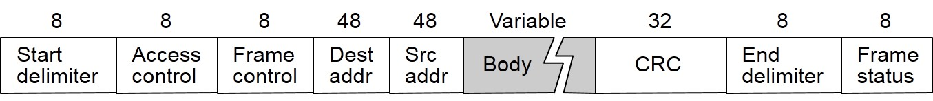

FDDI Frame Format
- 4B/5B control symbols for start and end of frame
- Control Field
  - 1st bit: asynchronous (0) versus synchronous (1) data
  - 2nd bit: 16-bit (0) versus 48-bit (1) addresses
  - Last 6 bits: demux key (includes reserved patterns for token and claim frame)
- Status Field
  - From receiver back to sender; error in frame
  - Recognized address; accepted frame (flow control)
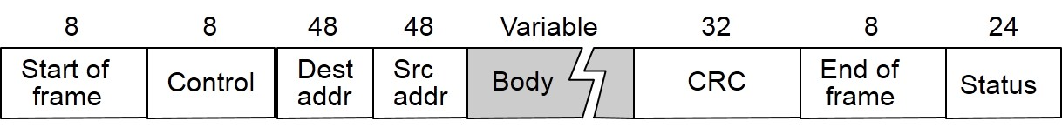

Frame Format for 802.11(Wireless)
- Control field contains three subfields:
  - 6-bit Type field (data, RTS, CTS, scanning);
  - 1-bit ToDS; and
  - 1-bit FromDS
- A single frame contains up to 2312 bytes of data

ATM Cell Format
- User-Network Interface (UNI)
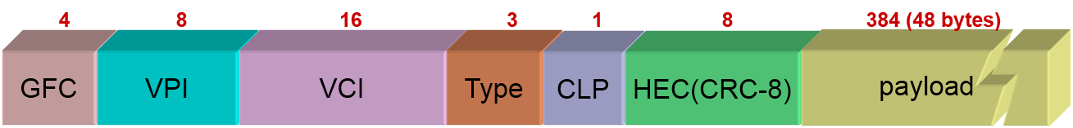
  - Host-to-switch format
GFC: Generic Flow Control
VCI/VPI: Virtual Circuit/Path Identifier
Type: management, congestion control, AAL5
  - CLP: Cell Loss Priority
  - HEC: Header Error Check (CRC-8)
Network-Network Interface (NNI)
  - Switch-to-switch format
  - GFC becomes part of VPI field
AAL 3/4
- Provides information to allow variable size packets to be sent in fixed-size ATM cells
- Convergence Sublayer Protocol Data Unit (CS-PDU)
  - CPI: Common Part Indicator (version field)
  - Btag/Etag:beginning and ending tags (same)
  - BAsize: hint on reassembly buffer space to allocate
  - Length: size of whole PDU
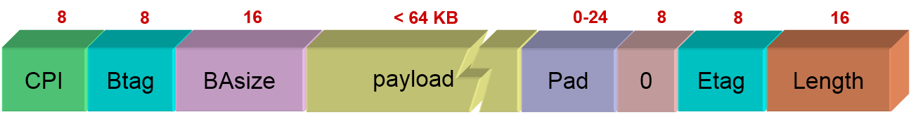
- Segmented into cells: header/trailer + 44-byte data

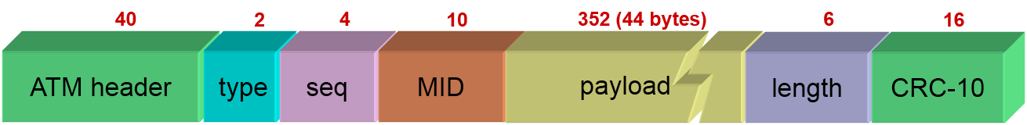
ATM Cell Format for AAL 3/4

- Type (is-start? and is-end? bits)
  - BOM (10): beginning of message
  - COM (00): continuation of message
  - EOM (01): end of message
  - SSM (11): single-segment message
- SEQ: sequence number (for cell loss/reordering)
- MID: multiplexing ID (mux onto virtual circuits)
- Length: number of bytes of PDU in this cell
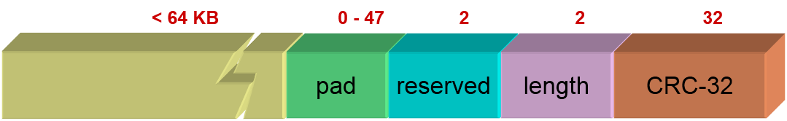
AAL 5 CS-PDU

  - Pad so trailer always falls at the end of ATM cell
  - Length: size of PDU (data only)
CRC-32 (detects missing or misordered cells)

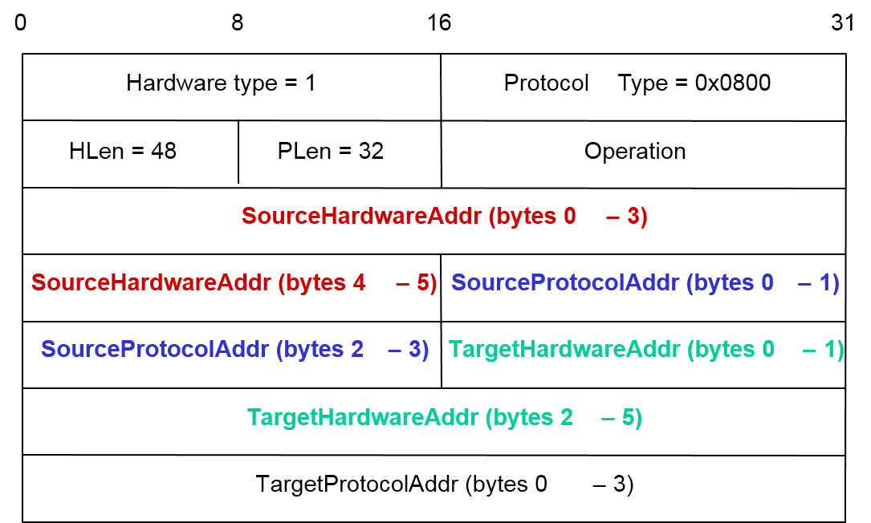
ARP Packet Format

