1. How reliability accomplish in reliable transmission.
2. Basic goals of forwarding packet switching
3. How ATM works in LAN
4. Clock synchronization problem in framing using distributed clock. how to solve this problem?
5. Distance vector route failure withy example
6. Link state algo working with example.
7. Note on switches

Token Ring
- Ring is viewed as a single shared medium
  - each node is allowed to transmit according to some distributed algorithm for medium access
  - all nodes see all frames; destination saves a copy of frame as it flows past
- Token is a special bit pattern that rotates around the ring
  - A node must capture token before transmitting
  - A node releases token after done transmitting
    - Immediate release- token follows last frame (FDDI)
    - Delayed release – after last frame returns to sender
- Stations get round-robin service as the token circulates around the ring
- When a node receives a claim frame, it compares the bid with its own bid
  - If its bid is higher, it updates TTRT & forward the frame
  - If its bid is lower, it replaces with its own claim frame
  - If bids are equal, higher address node wins
Physical Properties
- A node is connected into the ring using a relay
  - Relay is open as long as the station is alive (a)
  - Relay closes and bypasses the station if it is dead (b)
- Several relays are packed into a single box: multi Station Access Unit (MSAU)
- Data rate can be 4 Mbps or 16 Mbps
- Encoding of bits uses differential Manchester
- Ring may have up to 250 (802.5) or 260 (IBM) nodes
- Physical medium is twisted pair (IBM Token Ring)
Token Ring MAC
- Token circulates if no station has anything to send
  - Ring must have enough capacity to store entire token
  - Any station that has a data to send can seize token
  - In 802.5, simply 1 bit in second byte token is modified
  - First two bytes of modified token become preamble for the next frame
  - Intended recipient copies the frame into a buffer
  - Sender is responsible for removing these frames
  - Frame longer than the capacity of ring is drained by the sender while still transmitting its later part
  - A node captures the token and sends as much data as it has …
  - A node could keep the token for arbitrarily long time, and other nodes are not given the turn
Timed Token Algorithm
- Token Holding Time (THT)
  - A node checks before putting each frame on ring that its transmit time would not cause THT to exceed
  - Long THT achieves better utilization with few senders
  - Short THT helps when multiple nodes have data to send
  - TRT <= ActiveNodes x THT + RingLatency
Reliable Delivery
- The A and C bit in the packet trailer for reliability
- Both bits are initially set to 0
- Destination sets A bit if it sees the frame and sets C bit if it copies the frame into its adaptor
- If sender receives bit A=0, it assumes destination is absent (not functioning)
- If A bit is set but not bit C, it means destination is unable to accept the frame
  - Sender retransmits this frame later
- Strict priority scheme: no lower-priority packets get sent when higher priority packets are waiting
Token Maintenance
- Token rings have a designated monitor node
- Any station can become the monitor according to a well defined procedure
- Monitor is elected when the ring is first connected, or when the current monitor fails
- Monitor periodically announces its presence
- Claim token sent by a station seeing no monitor
  - if the sender receives back the claim token, it becomes monitor
  - if another station is also contending for monitor, some rule defines the monitor
Monitor’s Role
- May add additional delay into the ring
- Assures that a valid token is present in the ring because token may be lost:
  - No token when initializing the ring
  - Bit error corrupts token pattern
  - Node holding the token crashes
- Maintains a timer to detect the missing token
  - Timer = NumStations x THT + RingLatency
  - When times expires, it creates a new token
- Checks for corrupted frames
  - checksum error, invalid format, may circulate forever
  - Monitor drains them off the ring
- Checks for orphaned frames
  - sending station died before removing the frame
  - “Monitor” bit is used to detect orphaned frames
  - Initially 0, and set to 1 when a frame passes the monitor
  - If the monitor sees a frame with this bit set, it drains it off
Fiber Distributed Data Interface
- Similar to 802.5/IBM token rings but runs on fiber
- Consists of a dual ring: two independent rings that transmit data in opposite directions at 100Mbps
- Tolerates a single link break or node failure (self-healing ring)
Variable size buffer (9 - 80 bits)
  - Not required to fill buffer before starting transmission
- Maximum 500 stations, maximum 2 km distance between any pair of stations
- Physical media can be coax or twisted pair cable
- Uses 4B/5B encoding
  - TRT <= ActiveNodes x THT + RingLatency
- Target Token Rotation Time (TTRT)
  - “agreed-upon” or negotiated upper bound on TRT
MAC Algorithm
- Each node measures TRT between successive token arrivals
- If measured-TRT > TTRT
  - Token is late
  - Can not send data
- If measured-TRT < TTRT
  - Token is early so OK to send
FDDI MAC Issue
- If a node has lots of data, it holds the token for the maximum allowed time
- When a downstream neighbor gets the token, its measured TRT >= TTRT
  - It cannot transmit its frame!
FDDI Traffic Classes
- Synchronous traffic
  - Latency sensitive
  - Gets higher priority
  - Can always send data
- Asynchronous traffic
  - Sensitive to throughput rather than delay
  - Lower priority
  - Can send only if token is early
    - May cause the time to exceed by one FDDI frame

Token Maintenance Procedure
- A node sends a claim frame including its TTRT bid
- When a node receives a claim frame, it compares the bid with its own bid
  - If its bid is higher, it updates TTRT & forward the frame
  - If its bid is lower, it replaces with its own claim frame
  - If bids are equal, higher address node wins
- If a node’s claim frame returns back to it, it knows:
  - Its bid was the lowest
  - Everyone knows TTRT
  - It can now insert new token
Wireless LANs
- IEEE 802.11 standard
  - Designed for use in a small area (offices, campuses)
- Bandwidth: 1, 2 or 11 Mbps
  - Up to 56Mbps in newer 802.11a standard
- Targets three physical media
  - Two spread spectrum radio (2.4GHz freq)
  - One diffused infrared (10m range, 850 nm band)
Spread Spectrum
- Spread signal over wider freq band
- Pseudo-random sequence, signal looks like a noise
- Introduce pseudo-random component into signal
- Sender and receiver share Pseudorandom number generator and the seed
Frequency Hopping:
- Transmit over pseudo-random sequence of frequencies
- 802.11 uses 79 x 1MHz-wide frequency bands

Direct Sequence Spread Spectrum
- For each bit, send XOR of the bit and n random bits
- Random sequence is known to sender and receiver
- n random bits are called n-bit chipping code
- 802.11 defines an 11-bit chipping code 83MHz band

802.11 MAC: CSMA/CA
- Similar to Ethernet …
  - Defer the transmission until the link becomes idle
  - Take back off if collision occurs
Hidden and Exposed Nodes
- Hidden nodes
  - Sender thinks its OK to send when its not (false +ve)
  - A-C and B-D are hidden nodes in the figure below
- Exposed nodes
  - Sender does not send when its OK to send (false –ve)
  - B and C are exposed nodes in the figure below
Multiple Access with Collision Avoidance (MACA)
- Sender transmits RequestToSend (RTS) frame
  - contains intended time to hold the medium
- Receiver replies with ClearToSend (CTS) frame
- Neighbors of the receiver …
  - hear CTS: keep quiet for the intended duration (or till the ACK is heard)
- Neighbors of only the sender
  - hear RTS but not CTS: OK to transmit
  - Binary exponential back off (BEB) is used in case of collision, like in Ethernet
802.11 - Distribution System
- Nodes roam freely but operate within a structure
  - Each Access Point (AP) services nodes in some region
  - Each mobile node associates itself with an AP
- Scanning (active search for an AP)
  - node sends Probe frame
  - all AP’s within reach reply with Probe Response frame
- Passive scanning: AP periodically sends Beacon frame, advertising its capabilities
- Node may switch AP in response to beacon
  - if signal strength better from new AP
- 802.11 frames contain four addresses
  - actual sender and receiver (source and dest.)
AP for sender and receiver
- Nodes roam freely but operate within a structure

Network Adaptors
Components of a Network Adaptor
- Bus interface communicates with a specific host
- Link interface speaks correct protocol on network
- Buffering between different speed bus and link
Host Perspective
- Adaptor is ultimately programmed by CPU
- Adaptor exports a Control Status Register (CSR)
- CSR is readable and writable from CPU at some memory address
Data Motion Options for Network Adaptor Use
- Programmed input/output (PIO)
  - Processor manages itself each access (loads/stores)
  - Faster than DMA for small amounts of data
- Direct memory access (DMA)
  - Adaptor gets buffer descriptor lists by host for read/write
  - Processor is not involved: free to do other things
  - Can be faster than memory copy through CPU
  - Start-up cost
Performance Bottlenecks
- Link capacity
- Processor computing power
- I/O bus bandwidth
  - Overhead involved in each bus transfer
Why Switching ?
- Heterogeneity
  - switching allows multiple physical netwrk
  - but assume one switching strategy
  - Alternative: provide illusion of one physical network
  - Solution: Indirect connectivity by using switches
  - Packet switches in computer networks control frame flow
  - Multiple direct link networks, transparent to application
Packet Switches
- A multi-input multi-output device
- Local star topology
- Performance independent of connectivity

- First challenge: forwarding
- Packets arrive at one of the several inputs and have to be forwarded / switched to one of the available outputs
  - Connectionless and connection-oriented approach to determine the correct output
- Second challenge: routing
Contention and Congestion
Packet Switching / Forwarding
- Three approaches
  - Datagram or connectionless approach
  - Virtual circuit or connection-oriented approach
  - Source routing
Datagram Switching / Forwarding
- No connection setup phase (connectionless model)
- Analogy:
  - Postal system: each packet contains complete address for its destination
- No round trip time delay waiting for connection setup
  - Host can send data anywhere, anytime as soon as it is ready
Source has no way of knowing if the network is capable of delivering a packet or if the destination host is even up
- Every packet carry full address of the destination
  - Overhead per packet is higher than for the connection-oriented model
  - Global address to path translation requires storage
Virtual Circuit Switching
- Explicit connection setup (& tear-down) phase from source to destination: connection-oriented model
- Each switch maintains a VC table (connection state) per-link or per-switch
- Analogy
  - Phone call: each packet follows an established path
- VC table contains information for each connection
  - incoming / outgoing interface (port)
  - incoming / outgoing VCI (virtual circuit identifier)
- Permanent (PVC) or switched (signaled) virtual circuit (SVC)
- Setup message in signaling process (to create VC table) is forwarded like a datagram
- Acknowledgment of connection setup to downstream neighbors to complete signaling
  - Data transfer phase can start after ACK is received
Virtual Circuit Model
- Each data packet contains only a small identifier, making the per-packet header overhead small
Source Routing
- Packet header contains sequence of address/ports on path from source to destination
  - One direction per switch: port, next switch; (absolute)
  - Switches read, use, and then discard directions
- All forwarding/topology information required to switch a packet is provided by source host
- Used in some system area networks (SANs)
- Directions may be rotated instead of discarding
Source Routing Model
- Source host needs to know the correct and complete topology of the network
  - Changes must propagate to all hosts
- Packet headers may be large and variable in size: the length is unpredictable
- Each switch needs to correctly and efficiently manipulate the header information
  - Rotation or stripping of address
  - Pointer to current address
Bridges and Extended LANs
Bridges
- Connect two or more LANs with a bridge
  - Transparently extends a LAN over multiple networks
  - Accept & forward strategy (in promiscuous mode)
Bridges vs. Switches
- Switch
  - Receive frame on input port
  - Translate address to output port
  - Forward frame
- Bridge
  - Connect shared media
  - All ports bidirectional
  - Repeat subset of traffic
    - Receive frame on one port
    - Send on all other ports
Uses and Limitations of Bridges
- Limited scalability
- Not heterogeneous
- Frame drop because of bridge congestion
- Large and variable latency between two hosts
- Frames may reorder in extended LANs

Learning Bridges
- Learn table entries based on source address
  - Timeout entries to allow movement of hosts
- Table is an optimization; need not be complete
- Always forward broadcast frames
- Uses datagram or connectionless forwarding

- Problem
  - Redundancy (desirable to handle failures, but …)
  - Makes extended LAN structure cyclic
  - Frames may cycle forever
- Solution: spanning tree
Spanning Tree
- Initially, each bridge believes it is the root
  - Sends a configuration message, and checks if any received message is better than the current best message
- Each bridge records current best configuration message for each port
- Bridges forward configuration messages outward from root bridge i.e., on all designated ports
- Bridge assumes it is designated bridge for a LAN until it learns otherwise
- In steady state, only designated bridges forward configuration messages
  - Outward from root bridge, to all designated ports
  - Until they learn they are not designated bridge

ATM (Asynchronous Transfer Mode)
- Defined by ATM Forum (formed in Oct. 1991)
  - Data network industry
Telephone industry
- Connection-oriented packet-switched network
  - Virtual-circuit routing
Typically implemented on SONET
- Signaling (connection setup) Protocol: Q.2931
- ATM address format
  - E.164 and NSAP (Network Service Access Point)
  - Different from MAC addresses
Cell Switching (ATM)
- Fixed length (53 bytes) frames are called cells
  - 5-byte (header + 1-byte CRC-8) + 48-byte payload
- 2-level connection hierarchy
  - Virtual circuits
  - Virtual paths
    - Bundles of virtual circuits
    - Travel along common route
- Small data is sent in a minimum-sized packet
  - No need for extraneous padding
- Large file is sent by breaking it into many maximum-sized packets
Drawbacks of Fixed-length Frames
- No optimally good fixed length
- Higher overhead for large frames
  - Must be fragmented
  - One header per fragment (less efficient)
- Low utilization for small frames
  - Must be padded

Why Short Frames ?
- Shorter queues
  - Switches typically store and forward packets
  - Cannot send until full packet arrives
  - Short frames (fragmentation) allows first part to be sent while remainder arrives
- Consider 4kB vs. 53B frames, 100 Mbps link
- Preemption: high-priority frame arrives just as switch starts sending low-priority frame
  - 4kB: wait for 4096 x 8 / 100 = 327.68 microseconds
53B: wait for 53 x 8 / 100 = 4.24 us
- Shorter queues: two chunks (or frames) arrive simultaneously at time 0
  - 4kB: link is idle until all data arrive at time 327.68 us; 8 kB left to send
  - 53B: link nearly fully utilized (waits 4.24us); at time 327.68 microseconds, roughly 4kB left to send
Why 53-byte Frames ?
- Telephone community wish: carry voice effectively
- Demands ATM to improves latency for audio data
  - Voice encoded at 64kbps: 8-bit smpl at 8KHz
- Compromise: 48 bytes = 32(Europe) + 64(US) / 2
Segmentation and Reassembly(SAR)
- Variable-length packets passed to ATM are often larger than 48 bytes
  - May not fit in the ATM payload
- Fragmentation is required at the source
  - High-level message into low-level packets
- Destination reassembles the fragments
- ATM Adaptation Layer (AAL)
  - AAL header contains information for reassembly
  - AAL1, AAL2 for applications needing guaranteed rate
  - AAL3/4 designed for variable-length packet data
  - AAL5 is an alternative standard for packet data
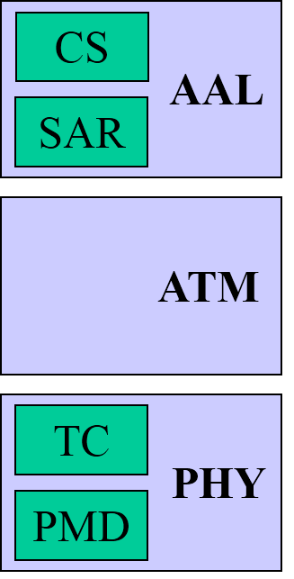
ATM Layers
AAL
  - Convergence Sublayer (CS) supports different application service models
  - SAR supports variable-length frames

ATM Layer
  - Handles virtual circuits, cell header generation, flow control
Physical layer
  - Transmission Convergence (TC) handles error detection, framing
  - Physical medium dependent (PMD) sublayer handles encoding
AAL 3/4 Summary
- Only 44 bytes of data in 53 bytes of cell
- CS-PDU encapsulation further reduces the efficiency
- Lot of overhead to perform simple function of segmentation and reassembly
AAL 5
- AAL 5 designed as replacement for AAL3/4
- No PDU information in ATM header
  - Only uses 1 bit of ATM header to mark end of PDU
  - Does not require additional per-cell headers/trailers
- CS-PDU contains data with only 8-byte trailer
  - Uses stronger error correct at PDU level (CRC-32)
  - Protection against lost, corrupt and misordered cells is provided by CS-PDU

Virtual Paths with ATM
- Two level hierarchy of virtual connection: 8-bit VPI and 16-bit VCI
  - Switches in the public network use 8-bit VPI
  - Corporate sites use full 24-bit address (VPI + VCI)
  - Virtual path: fat pipe with bundle of virtual circuits
Physical Layers for ATM
ATM and LANs
- ATM grew out of the telephone community and later used for computer communication
- No distance limitation in ATM making it a good choice for high-performance LAN backbone
- Point-to-point, long distance Gigabit Ethernet is a competing technology with ATM
- Different from traditional LANs; no native support for broadcast or multicast
- How to broadcast to all nodes on an ATM LAN ?
  - Without knowing all the addresses
  - Without setting up VC to all of them
- Two solutions
  - Redesign protocols that consider LAN different from what ATM can provide (e.g. ATMARP)
  - Make ATM behave like shared media, without loosing performance advantage of switched media (e.g. LANE)
LAN Emulation (LANE) with ATM
- Devices connect as LAN Emulation Clients (LEC)
- LANE provides Ethernet-like interface to LECs
Clients and Servers in LANE
- LAN Emulation Client (LEC)
  - Host, bridge, router or switch
- LAN Emulation Server (LES)
  - Maintains client’s MAC and ATM addresses
  - Maintains ATM address of BUS
- LAN Emulation Configuration Server (LECS)
  - High-level network management when LEC starts up
  - Reachable by preset VC
  - Maintains mapping of ATM address to LANE type
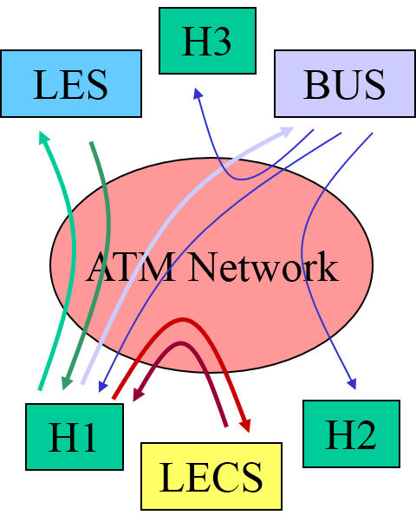
LANE Registration
- Client contacts LECS on predefined VC, and sends ATM address to it
- LECS returns LAN type, MTU and ATM address of LES
- Client signals connection to LES, and registers MAC and ATM addresses with LES
- LES returns ATM address of BUS
- Client signals connection to BUS
- Bus adds client to point-to-multipoint VC
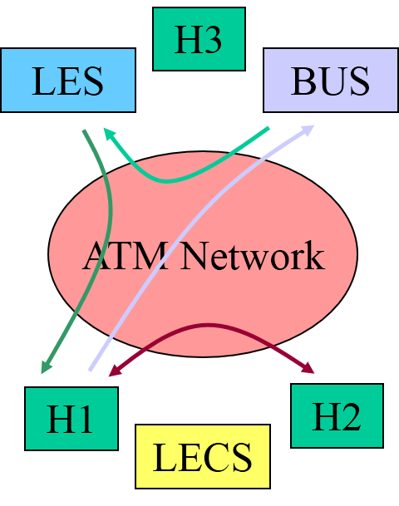
LANE Circuit Setup
- Client (H1) knows destination MAC address of receiver (H2)
- Client (H1) sends 1st packet to BUS
- BUS sends address resolution request to LES
- LES returns ATM address to client (H1)
- Client (H1) signals connection to H2 for subsequent packets

Switching Fabric
- Special-purpose (switching) hardware
- General problem
  - Connect N inputs to M outputs (NxM switch)
  - Often N=M (bidirectional links)
- Design goals
  - High throughput: want aggregate close to
MIN (sum of inputs, sum of outputs)
  - Avoid contention (fabric faster than ports)
  - Good scalability:linear size/cost groth in N/M
Design Goals – Throughput
- An n x m switch can provide max ideal throughput of S = S₁ + S₂ + ……… + S_{n}
  - Sustained throughput higher than link speed of output is not possible
  - Variable size packets affect performance
  - Most switches are subject to internal contention
  - Traffic models are important to throughput
  - Designers now expect high range of throughputs
Design Goals – Scalability
- Cost of hardware rises fast with increasing the number of ports n
- Design complexity determines maximum switch size
Switch Performance
- Avoid contention with buffering
  - Use output buffering when possible
  - Apply backpressure through fabric
  - Drop packets if input buffer overflows
Self-Routing Fabrics
- Use source routing on “network” within switch
- Input port attaches output port number as header
- Fabric routes packet based on output port
- Types
  - Banyan network
  - Batcher-Banyan network
  - Sunshine switch

IP Datagram Format
V
ersion
HLen
TOS
Length
Ident
Flags
Offset
TTL
Protocol
Checksum
SourceAddr
DestinationAddr
Options (variable)
Pad
(variable)
0
4
8
16
19
31
Data

- 4-bit version (4 for IPv4, 6 for IPv6)
- 4-bit header length (in words, minimum of 5)
- 8-bit type of service (TOS); more or less unused
- 16-bit datagram length (in bytes)
- 8-bit protocol (e.g., TCP=6 or UDP=17)
- Fragmentation support
  - 16-bit packet ID (identifies packet fragments)
  - 3-bit flags; one bit marks last fragment
  - 13-bit fragment offset into packet (in 8-byte words)
- 8-bit “time-to-live” (TTL); a hop count until forced destruction of packet
- 16-bit IP checksum on header
- 32-bit source IP address
- 32-bit destination IP address
- Options and padding (variable length)
  - Source-based routing (typically disabled)
  - Record route
  - Several others
Internet Control Message Protocol (ICMP)
- IP companion protocol
- Handles error and control messages
ICMP Message
- Error messages
  - Destination unreachable (protocol, port, or host)
  - Reassembly failed
  - IP Checksum failed; or invalid header
  - TTL exceeded (so datagrams don’t cycle forever)
  - Cannot fragment
- Control messages
  - Echo (ping) request and reply
  - Redirect (from router to source host, to change route)

Dynamic Host Configuration Protocol- DHCP
- DHCP server is required to provide configuration information to each host
  - Each host retrieve this information on bootup
- DHCP server can be configured manually, or it may allocate addresses on-demand
  - Addresses are “leased” for some period of time
- Each host is not configured for DHCP server, it performs a DHCP server discovery
  - A broadcast discovery message is sent by the host and a unicast reply is sent by the server
IP Tunneling
IP Tunnel in VPNs
- Virtual point-to-point link between a pair of nodes separated by many networks
Routing
Bellman-Ford Algorithm
- For every node N
  - For each directed pair (B,C)
    - Is the path B N …C better than B .C ?
    - Is cost BNdest smaller than previously known?
- For N nodes
  - Uses an NxN matrix of (distance, successor) values
Dijkstra’s Algorithm
- From node N
  - Start with S = {N} and one-hop paths from N
  - Loop n-1 times
    - Add closest outside node M to S
    - For each node P not in S
      - Is the path N ..... M ..... P better than N ..... P ?
Distance Vector Routing: Link Failure
- F detects that link to G has failed
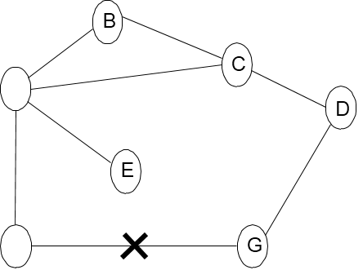
- F sets distance to G to infinity and sends update to A
- A sets distance to G to infinity since it uses F to reach G
- A receives periodic update from C with 2-hop path to G
- A sets distance to G to 3 and sends update to F
- F decides it can reach G in 4 hops via A

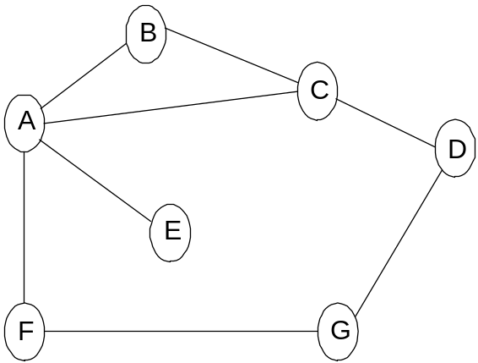
Count to Infinity Problem
- Link from A to E fails
- A advertises distance of infinity to E, but B and C advertise a distance of 2 to E !
- B decides it can reach E in 3 hops; advertises this to all
- A decides it can read E in 4 hops; advertises this to all
- C decides that it can reach E in 5 hops…
- We are counting to infinity …
Route Calculation: Dijkstra’s Shortest Path Algorithm
- Let
  - N denotes set of nodes in the graph
  - l (i, j) denotes non-negative cost (weight) for edge (i, j)
  - s denotes this node
  - M denotes the set of nodes incorporated so far
  - C(n) denotes cost of the path from s to node n
M = {s}
for each n in N - {s}
C(n) = l(s, n) // calculate cost to each node
while (M != N)
M = M union {w} such that C(w) is the minimum for
all w in (N - M)
for each n in (N - M)
C(n) = MIN(C(n), C (w) + l(w, n ))

Link State Algorithm
- Initialize confirmed with entry for self (cost = 0)
- For newly added node (next), select its LSP
- For each neighbor of next, calculate cost to reach neighbor as the sum of cost from self to next and from next to neighbor
  - If neighbor is currently in neither confirmed nor tentative, add <neighbor, cost, nexthop> to tentative, where nexthop is the direction to reach next
  - If neighbor is currently in tentative and cost is less than current cost for neighbor , then replace current entry with <neighbor, cost, nexthop>, where nexthop is the direction to reach next
- If tentative is empty, stop. Otherwise pick entry from tentative with the lowest cost, move it to confirmed and return to step 2.

OSPF Routing Protocol
- Authentication of routing messages
  - Encrypted communication between routers
- Additional hierarchy
  - Domains are split into areas
  - Routers only need to know how to reach every node in a domain
  - Routers need to know how to get to the right area
  - Load balancing
    - Allows traffic to be distributed over multiple routes

